**Lesson 6**

(5 min)

Logistics

* Does everyone have their local dev environments set up? Progress check

(5 min)

Cool Alexa Skill demo: 1-2 students

Talk about it with respect to 7 UX factors

(15 min)

**Alexa Components Recap** — show the diagram below / [components handout](https://github.com/sh35/Beyond-the-GUI/blob/master/Handouts/Alexa%E2%80%99s%20Architectural%20Components.pdf)

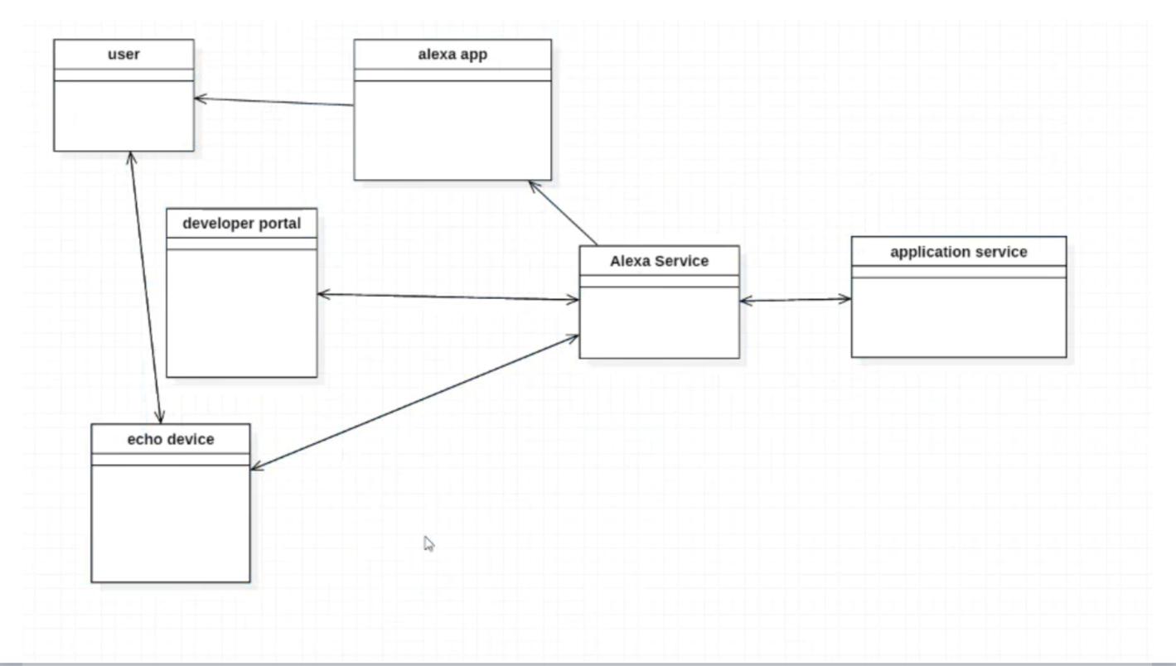

1. **Alexa Developer Portal** — <https://developer.amazon.com/>
   1. Point out where this is on the architectural flow diagram
   2. Skill Information
   3. Interaction Model — this is the voice interface through which users interact with the skill
      1. Create [Intents, Utterances, and Slots](https://developer.amazon.com/docs/custom-skills/create-intents-utterances-and-slots.html)
   4. Configuration — indicate what the endpoint refers to
   5. Test - Service Simulator
2. **AWS Lambda** — <https://console.aws.amazon.com>
   1. This is a server less computing platform provided by Amazon as a part of AWS
   2. It is basically a compute service that runs code in response to events and automatically manages the compute resources required by that code
   3. So all we have to do is give the service that code, and it will take care of the rest for us
   4. Show code — in Eclipse
   5. Talk about how to upload code to Lambda function — upload as a jar file
      1. Need to use Maven (build automation tool) to build the jar file with all the dependencies
3. Demo — “Alexa open hello world demo”
   1. Type into simulator
   2. Say to Echo
   3. Uh oh… she couldn’t respond properly

(15 min)

Breakout groups — Zoom

Your task:

* Look at Java service code (in [codeshare.io](http://codeshare.io)) and determine the flow for a sample request
* Highlight / comment lines that you don’t understand
* [ASK Java docs](https://developer.amazon.com/public/solutions/alexa/alexa-skills-kit/javadocs/alexa-skills-kit-java-library-reference)
  + <https://developer.amazon.com/public/solutions/alexa/alexa-skills-kit/javadocs/alexa-skills-kit-java-library-reference>
  + Use this to understand what’s going on in the Service code
* Figure out what’s wrong — why isn’t she responding?
  + “Alexa, open hello world demo”
  + “Welcome to the Alexa Skills Kit, you can say hello”
  + “Hello”
  + “There was a problem with the requested skill’s response.”

(10 min)

Whole class — BlueJeans

* Did anyone manage to fix the error?
* One group present their path flow for a sample request
* What did you not understand?
* Does anyone have answers?

(5 min)

Wrap Up